Poročilo naloga Neo4j



Primož Ratej Cvahte

Podatkovne baze II

ITK-VS

Jan-2018

Vsebina

# Import data

## About cypher

Cypher je deklarativni grafični poizvedbeni jezik, ki omogoča ekspresivno in učinkovito poizvedovanje in posodabljanje dela nad grafi. Cypher je relativno preprost, vendar zelo močan jezik. Zelo zapletene poizvedbe v bazo podatkov lahko enostavno izrazite s Cypherjem. To omogoča uporabnikom, da se osredotočijo na svojo domeno, namesto da bi se izgubili v dostopu do baze podatkov.

## Import cypher

Najprej smo uvozili podatke z poizvedovalnim jezikom cypher. Zaganjamo vsak query posebej. Podatke pa zajemamo z GitHub-a.

// Legis-graph LOAD CSV cypher script

// https://github.com/legis-graph/legis-graph

// Load Legislators

CREATE INDEX ON :Legislator(bioguideID);

CREATE INDEX ON :Legislator(thomasID);

CREATE INDEX ON :Legislator(lisID);

CREATE INDEX ON :Legislator(govtrackID);

CREATE INDEX ON :Legislator(opensecretsID);

CREATE INDEX ON :Legislator(votesmartID);

CREATE INDEX ON :Legislator(cspanID);

CREATE INDEX ON :Legislator(wikipediaID);

CREATE INDEX ON :Legislator(washpostID);

CREATE INDEX ON :Legislator(icpsrID);

LOAD CSV WITH HEADERS

FROM 'https://raw.githubusercontent.com/legis-graph/legis-graph/master/outputs/legislators-current.csv' AS line

WITH line WHERE line.thomasID IS NOT NULL

MERGE (legislator:Legislator { thomasID: line.thomasID })

ON CREATE SET legislator = line

ON MATCH SET legislator = line

MERGE (s:State {code: line.state})

CREATE UNIQUE (legislator)-[:REPRESENTS]->(s)

MERGE (p:Party {name: line.currentParty})

CREATE UNIQUE (legislator)-[:IS_MEMBER_OF]->(p)

MERGE (b:Body {type: line.type})

CREATE UNIQUE (legislator)-[:ELECTED_TO]->(b);

// Load Bills

USING PERIODIC COMMIT

LOAD CSV WITH HEADERS

FROM 'https://raw.githubusercontent.com/legis-graph/legis-graph/master/outputs/bills.csv'

AS line

MERGE (bill:Bill { billID: line.billID })

ON CREATE SET bill = line

ON MATCH SET bill = line;

CREATE INDEX ON :Bill(billID);

// Load

LOAD CSV WITH HEADERS

FROM 'https://raw.githubusercontent.com/legis-graph/legis-graph/master/outputs/subjects.csv' AS line

MERGE (subject:Subject { title: line.title });

CREATE INDEX ON :Subject(title);

// Load Congresses

LOAD CSV WITH HEADERS

FROM 'https://raw.githubusercontent.com/legis-graph/legis-graph/master/outputs/congresses.csv' AS line

MERGE (congress:Congress { number: line.number });

// Laod Bills Congresses

USING PERIODIC COMMIT

LOAD CSV WITH HEADERS

FROM 'https://raw.githubusercontent.com/legis-graph/legis-graph/master/outputs/bill_congresses.csv'

AS line

MATCH (bill:Bill { billID: line.billID }),

(congress:Congress { number: line.number })

MERGE (bill)-[r:PROPOSED_DURING]->(congress);

// Load Bills Subjects

USING PERIODIC COMMIT

LOAD CSV WITH HEADERS

FROM 'https://raw.githubusercontent.com/legis-graph/legis-graph/master/outputs/bill_subjects.csv'

AS line

MATCH (bill:Bill { billID: line.billID }),

(subject:Subject { title: line.title })

MERGE (bill)-[r:DEALS_WITH]->(subject);

// Load Bills Legislators

// Load current sponsorships

USING PERIODIC COMMIT

LOAD CSV WITH HEADERS

FROM 'https://raw.githubusercontent.com/legis-graph/legis-graph/master/outputs/sponsors.csv'

AS line

MATCH (bill:Bill { billID: line.billID }),

(legislator:Legislator { bioguideID: line.bioguideID })

MERGE (bill)-[r:SPONSORED_BY]->(legislator)

ON CREATE SET r.cosponsor = line.cosponsor;

// Load Votes

USING PERIODIC COMMIT

LOAD CSV WITH HEADERS

FROM 'https://raw.githubusercontent.com/legis-graph/legis-graph/master/outputs/votes.csv'

AS line

MATCH (bill:Bill { billID: line.billID }),

(legislator:Legislator { bioguideID: line.bioguideID })

MERGE (bill)<-[r:VOTED_ON]-(legislator)

ON CREATE SET r.vote = line.vote;

// Load Committees

LOAD CSV WITH HEADERS

FROM 'https://raw.githubusercontent.com/legis-graph/legis-graph/master/outputs/committees-current.csv' AS line

MERGE (c:Committee {thomasID: line.thomasID})

ON CREATE SET c = line

ON MATCH SET c = line;

LOAD CSV WITH HEADERS

FROM 'https://raw.githubusercontent.com/legis-graph/legis-graph/master/outputs/bill_committees.csv' AS line

MATCH (b:Bill {billID: line.billID})

MATCH (c:Committee {thomasID: line.committeeID})

CREATE UNIQUE (b)-[:REFERRED_TO]->(c);

CREATE INDEX ON :Committee(thomasID);

// Load Committee Members

LOAD CSV WITH HEADERS

FROM 'https://raw.githubusercontent.com/legis-graph/legis-graph/master/outputs/committee-members.csv' AS line

MATCH (c:Committee {thomasID: line.committeeID})

MATCH (l:Legislator {bioguideID: line.legislatorID})

CREATE UNIQUE (l)-[r:SERVES_ON]->(c)

SET r.rank = line.rank;

// Create District nodes

LOAD CSV WITH HEADERS

FROM 'https://github.com/legis-graph/legis-graph/blob/master/outputs/cb_2014_districts.csv?raw=true' AS line

CREATE (d:District)

SET d.state = line.state,

d.district = line.district,

d.wkt = line.polygon

WITH d,line

MATCH (l:Legislator) WHERE l.state = line.state AND l.district = line.district

CREATE UNIQUE (l)-[:REPRESENTS]->(d);

## Import CSV

Datoteka CSV Game of Thrones prikazuje povezave oz. sodelovanja med karakterji ter moč med njihovimi povezavami. Datoteko CSV prenesemo z eštudija.

Najprej moramo ustvariti omejitev, da bi potrdili celovitost naše sheme:

CREATE CONSTRAINT ON (c:Character) ASSERT c.name IS UNIQUE;

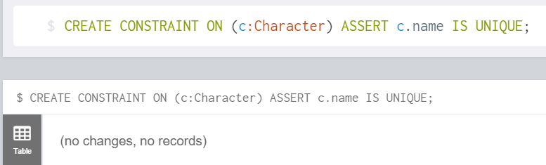

Slika 1 Create constraint

Datoteko CSV prenesemo v mapo Import ter jo uvozimo.

LOAD CSV WITH HEADERS FROM "file:///GameOfThrones.csv" AS row

MERGE (src:Character {name: row.Source})

MERGE (tgt:Character {name: row.Target})

MERGE (src)-[r:INTERACTS]->(tgt)

ON CREATE SET r.weight = toInt(row.Weight)

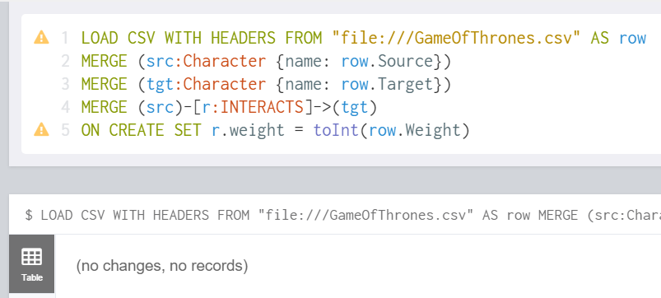

Slika 2 Import CSV

## American Congress

1. Izpišite vse člane kongresa, ki se pišejo Smith.

MATCH (n {lastName:"Smith"}) return n;

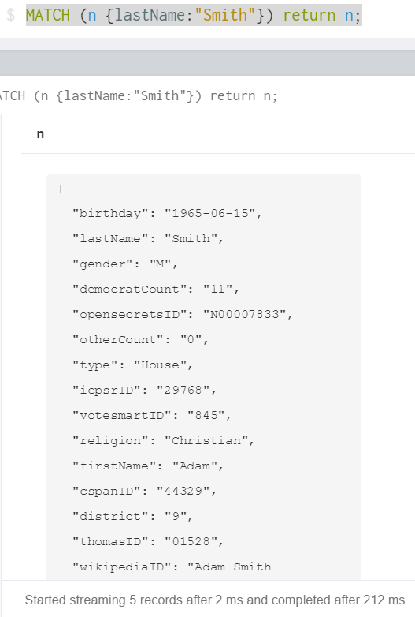

Slika 3 Kongres_01

1. Izpišite vse zakone, ki so jih sponzorili republikanci iz Kalifornije, ki so starejši od 65 let.

MATCH (leg:Legislator), bl=(bill)-[sp_by:SPONSORED_BY]->(:Legislator)

WHERE leg.state="CA" AND leg.birthday>"1952-02-09" RETURN bl LIMIT 20;

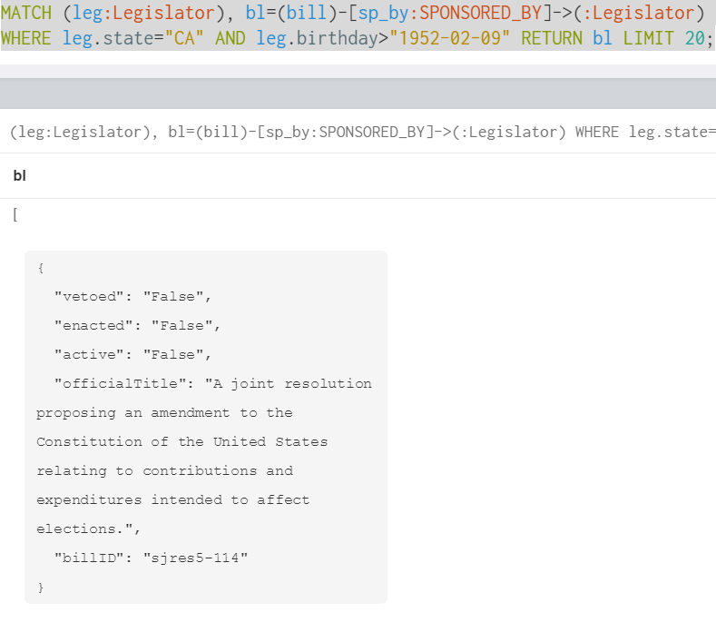

Slika 4 Kongres_02

1. Preštejte, za koliko zakonov je pozitivno glasoval Robert Aderholt.

MATCH (leg:Legislator {firstName: 'Robert',lastName:'Aderholt'})-[vot:VOTED_ON]->(bl:Bill)

WHERE vot.vote = 'Yea' OR vot.vote = 'Aye'

RETURN count(bl), leg.lastName

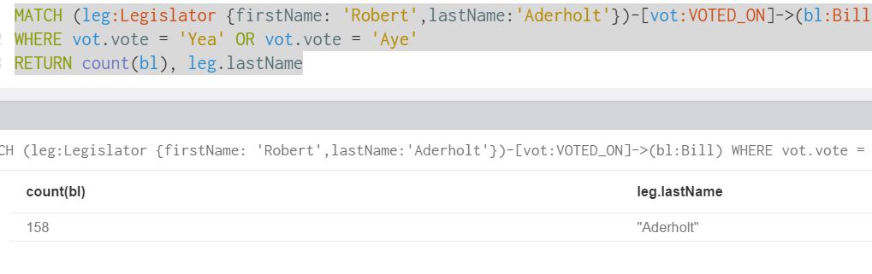

Slika 5 Kongres_03

1. Koliko zakonov je bilo skupno predlaganih na 114. kongresu, in koliko od teh je trenutno aktivnih?

MATCH (con:Congress {number:"114"})

WITH con, size(()-[:PROPOSED_DURING]->(con)) as Proposed

MATCH (bl:Bill {active:"True"})-[:PROPOSED_DURING]->(con)

RETURN Proposed, count(bl) as active

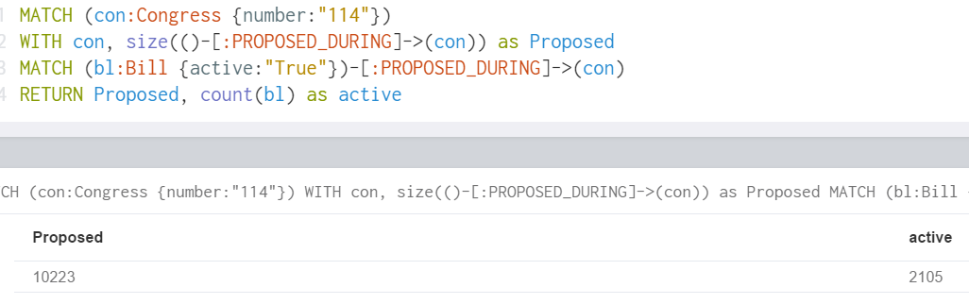

Slika 6 Kongres_04

1. Izpišite vse zvezne države, ki imajo v kongresu večino demokratov.

MATCH (leg:Legislator)-[rep:REPRESENTS]->(sta:State)

WITH sta AS drzave, sum(size((leg{currentParty:"Democrat"})-[rep]->(sta))) AS sumDemo,

sum(size((leg{currentParty:"Republican"})-[rep]->(sta))) AS sumRep

WHERE sumDemo>sumRep

RETURN drzave.code

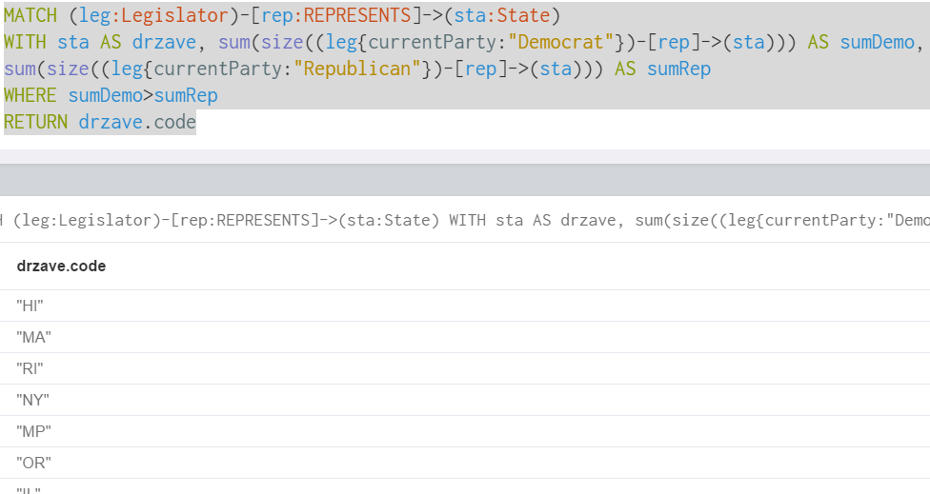

Slika 7 Kongres_05

1. S pomočjo grafa vizualizirajte vse predstavnike zvezne države Ohio, izvoljene v obe telesi kongresa, pri čemer prikažite tudi njihovo pripadnost stranki.

MATCH (sta:State {code: "OH"})<-[:REPRESENTS]-(leg:Legislator)

MATCH (leg)-[imo:IS_MEMBER_OF]->(par:Party)

WITH par.name as party, count(imo) as count

RETURN party, count;

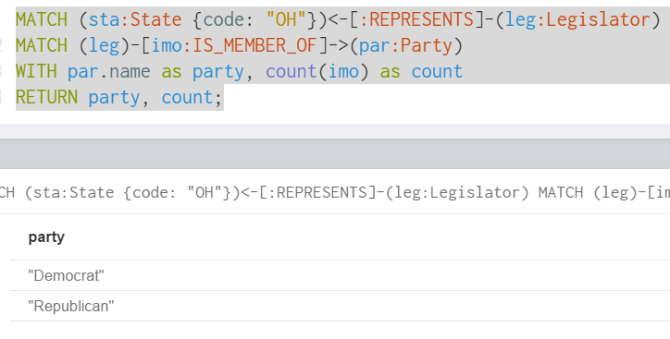

Slika 8 Kongres_06

1. Vizualizirajte vse senatorje iz Floride, in prikažite v katerih komitejih so aktivni.

MATCH (leg:Legislator)-[el_to:ELECTED_TO]->(bo:Body{type:"Senate"})

MATCH (leg)-[ser:SERVES_ON]->(com:Committee)

MATCH (leg)-[rep:REPRESENTS]->(sta:State{code:"FL"})

RETURN leg, com, bo, sta;

1. Kakšne zakone obravnavajo komiteji iz točke 7, in s kakšno problematiko (predmet zakona) se ti zakoni ukvarjajo?

MATCH (leg:Legislator)-[se:SERVES_ON]->(com:Committee)

MATCH (leg)-[rep:REPRESENTS]->(st:State{code:"FL"})

MATCH (bi:Bill)-[de_wi:DEALS_WITH]->(sub:Subject)

RETURN sub

LIMIT 20;

## Game of thrones

1. Koliko je minimalno, maksimalno in povprečno število karakterjev, s katerimi so sodelovali karaterji?

MATCH (cha:Character)-[:INTERACTS]->()

WITH cha, count(*) AS num

RETURN min(num) AS min, max(num) AS max, avg(num) AS avg

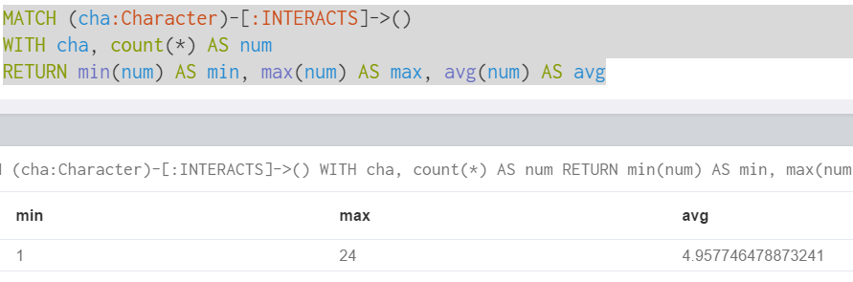

Slika 9 GOT_01

1. Poiščite vse možne najkrajše poti med karakterjema Jeoffrey Lanister in Khal Drogo.

MATCH (dick:Character{name:"Joffrey"}), (Khal:Character{name:"Drogo"})

MATCH path=allShortestPaths((dick)-[INTERACTS*]-(Khal))

RETURN path;

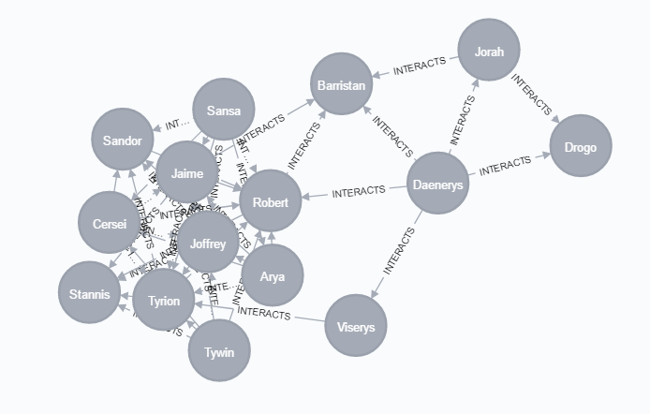

Slika 10 GOT_02

1. Poiščite maksimalno najkrajšo pot med dvema karakterjema.

MATCH (char_x:Character), (char_y:Character) WHERE id(char_x) > id(char_y)

MATCH nodes=shortestPath((char_x)-[:INTERACTS*]-(char_y))

RETURN length(nodes) AS nodes, extract(x IN nodes(nodes) | x.name) AS numOfNodes

ORDER BY nodes DESC LIMIT 5;

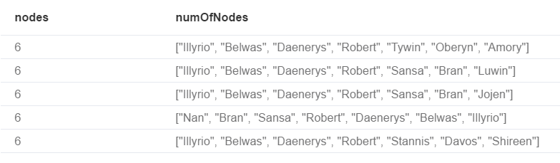

Slika 11 GOT_03

1. Poiščite vse karakterje, ki se pojavijo na vsaki najkrajši možni poti med karakterjema Robert Arryn in Aegon.

MATCH (Robert:Character {name: "Robert Arryn"}), (Aemon:Character {name: "Aemon"})

MATCH nodes=allShortestPaths((Robert)-[INTERACTS*]-(Aemon))

RETURN nodes;

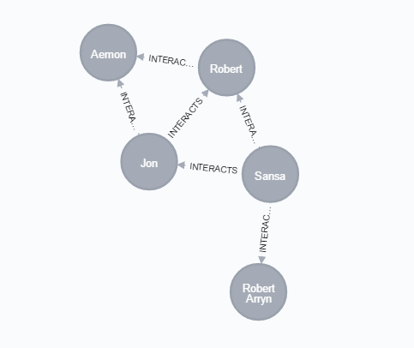

Slika 12 GOT_04

1. Izpišite prvih pet karakterjev, ki imajo največ povezav z drugimi karakterji, in prvih pet karakterjev, ki imajo najmanj povezav z drugimi karakterji (in izpišite število povezav).

MATCH (char:Character)

RETURN char.name AS Character, size( (char)-[:INTERACTS]-() ) AS min

ORDER BY min LIMIT 5

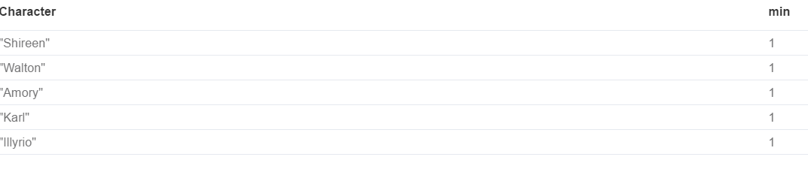

Slika 13 GOT_05.1

MATCH (char:Character)

RETURN char.name AS Character, size( (char)-[:INTERACTS]-() ) AS max

ORDER BY max DESC LIMIT 5;

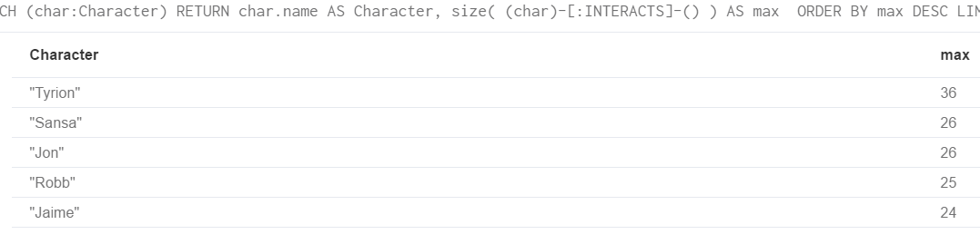

Slika 14 GOT_05.2

1. Izpišite prvih pet (in zadnjih pet) karakterjev, ki imajo največjo povprečno težo sodelovanj z drugimi karakterji.

MATCH (char:Character)-[inter:INTERACTS]->()

RETURN DISTINCT(char.name) AS character, AVG(inter.weight) AS weight

ORDER BY weight LIMIT 5;

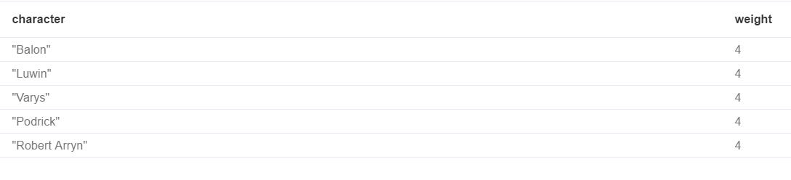

Slika 15 GOT_06.1

MATCH (char:Character)-[inter:INTERACTS]->()

RETURN DISTINCT(char.name) AS character, AVG(inter.weight) AS weight

ORDER BY weight DESC LIMIT 5;

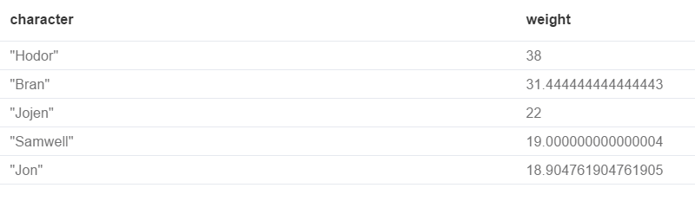

Slika GOT_06.1